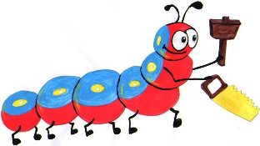

Lyng Primary School Knowledge Organiser

Design Technology

How can we prepare a healthy lunch?

Spring

Year 3

Topic: DT

|  |  |
| --- | --- |
| What Goldilocks and Step On words will I use? | |
| **Spelling** | **Defintion** |
| **cater** | To cater for a group of people means to provide all the things that they need or want |
| **evaluate** | If you evaluate something,you consider them in order to make a judgment about them, for example about how good or bad they are. |
| **food groups** | The categories which different foods may be placed according to the type of nourishment they supply, such as carbohydrates or proteins. |
| **healthy** | Something that is healthy is good for your health. |
| **hygienic** | Something that is hygienic is clean and unlikely to cause illness. |
| **ingredients** | Ingredients are the things used to make something, especially different foods when you are cooking a dish. |
| **intolerance** | An allergy or sensitivity to some food, medicine, etc. |
| **savoury** | Savoury food has a salty or spicy flavour rather than a sweet one. |
| **varied diet** | If you eat a varied diet, you know you will not be missing out on vital nutrients. |



**Design Brief for pupils:**

* Grow your own produce to use in a healthy food product.
* Research a healthy balanced diet.
* Plan sandwich combinations that cater for a person’s dietary requirements.

**Purpose:** through following the Young Chef Award, children will create a range of a healthy snacks, salads and smoothies that they could include in a balanced diet.

**Audience:** Year 3 teachers



|  |
| --- |
| Skills and techniques |
| * **Design** with **purpose** by identifying opportunities to **design.** * Make products by **working efficiently** (such as by carefully selecting materials). * **Prepare ingredients hygienically** using appropriate utensils. * Follow a **recipe.** * **Assemble** or cook **ingredients** (controlling the temperature of the oven or hob, if cooking). * **Refine work** and **techniques** as work progresses, continually **evaluating the product design.** |

Spring Term - Food

Using edible garden produce

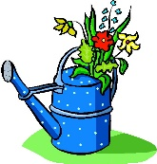

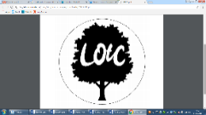

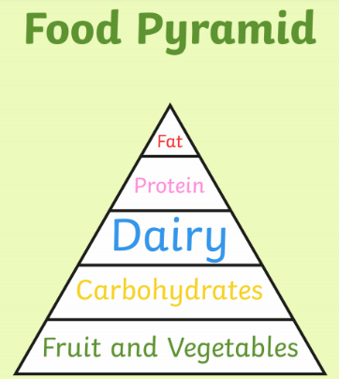

**Different food groups -** Each one of the five food groups is important:

* Fruit and vegetables, for example, apples, bananas and broccoli, give us vitamins to keep our bodies working and help our immune system and fibre to help our digestion.
* Carbohydrates, like pasta, bread and rice, keep our energy levels up.
* Proteins, such as meat, beans, and eggs, build healthy muscles and allow our bodies to grow and repair.
* Dairy, like milk, cheese and yoghurt, gives us calcium for strong teeth and bones.
* Fats and oils, for example olive oil and butter, act as an energy store.

**Agreed outcome:** To make a range of healthy snacks and meals including salads, dips and smoothies following the Young Chef Award.